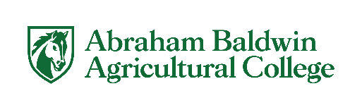

Letter of Authorization to Conduct Research at Facility

SAMPLE
*Correspondence must be on the facility’s letterhead*

[cut and paste all below to your document]

Office of the Provost – Institutional Review Board
Abraham Baldwin Agricultural College
Carlton Center - 215
2802 Moore Hwy, Tifton, GA 31793

Subject: Letter of Authorization to Conduct Research at .

Dear Office of Research Integrity – Human Subjects:

This letter will serve as authorization for the Abraham Baldwin Agricultural College
researcher/research team, [PI name must be included] to conduct the research project entitled at [facility name and location] .

(location) acknowledges that it has reviewed the protocol presented by the researcher, as well as the associated risks. We accept the protocol and the associated risks and authorizes the research project to proceed. The research project may be implemented at the Facility upon approval from the Abraham Baldwin Agricultural College Institutional Review Board.

If we have any concerns or require additional information, we will contact the researcher, the IRB at IRB@stallions.abac.edu and/or the Office of Sponsored Programs at SponsoredPrograms@abac.edu.

Sincerely,

Facility’s Authorized Signatory Date

Printed Name and Title of Authorized Signatory

